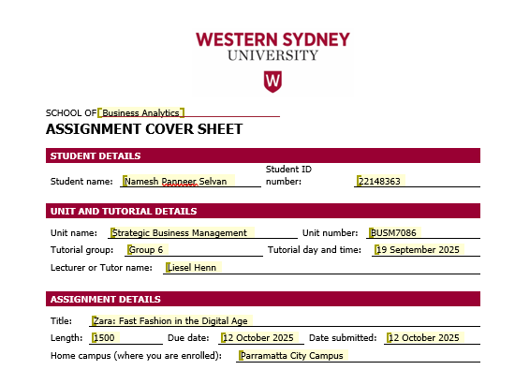
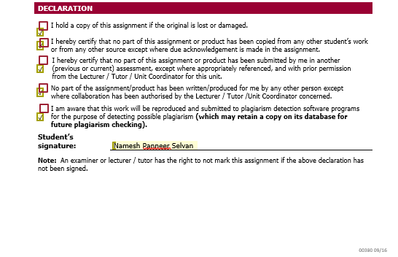

Zara: Fast Fashion in the Digital Age

Introduction:

With rapidly growing e-commerce websites in 2017, Amazon became one of the largest retailers in clothing industry in the United States. On the other hand, Inditex with a sale of €25.3 billion in 2017, were facing significant challenges in adapting its business strategies to the digitisation of retail industry. Their “fast fashion” strategy had helped them to expand their business from 622 stores to 2100 stores across 96 countries with a 16% CAGR in the past 20 years. Brands like Zara, H&M, and other fashion retailers were partnered with Inditex as their flagship brands. However, brands like Amazon and Nike challenged the long-standing advantage of Zara through their tech-driven approach.

Amancio Ortega the founder of Inditex (Industria de Diseno Textil) established the company in 1963 in Spain for selling gowns and dresses. They were majorly focusing on physical retail presences to a digital-first environment without compromising its brand essence. The top management of the company had to strategies their operational and design agility plans to adapt to the e-commerce and data-driven decision making to advance their business in the modern world.
The digital transition of Zara raised questions on their efficiency as a brand to sustain in the digital world. The case study of Zara explores the balance between innovation and traditional strengths with a pressure towards sustainability in the modern world of e-commerce.

This case study will analyse Zara in reference to the strategies implemented with reference to the below questions.

Q1: Identify and analyse three strategy paradoxes that shaped the evolution of your chosen case study’s business and corporate strategies?

Q2: Based on your analysis, what business and corporate strategy would you recommend to executives of your chosen case study? What are the main industry and environmental forces driving your recommendation according to Porter’s 5 Forces and PEST analysis that supports this recommendation?

Internal Analysis:

Internal analysis emphasises on the firm’s competitive advantage from its internal configuration of resources, activities, and product offering, which collectively forms the business model of a company.

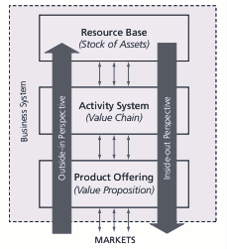
Below are the components of business model for Zara:
- Resource Base – In-house design, real-time data system, and end-to-end supply chain integration.

- Activity System – Seamless digital integration, fast production and logistic centralisation.

- Product Offering – Offers trendy and stylish clothing in affordable prices.

The strategic evolution of Zara can be analysed through the “Markets and Resources” paradox (de Wit 2020, pp. 196–207). It clearly captures the tension between market adaptation (outside-in perspective) and capitalising internal strengths and resources (inside-out perspective).

- Market Adaptation vs Capitalising internal strengths and resources:

- Market Adaptation: Competitors like Amazon, who were dominating the e-commerce industry created a tremendous pressure on Zara to digitise their business so that they can reach a larger audience and remain competitive in the market (de Wit 2020, p. 656).

- Capitalising internal strengths and resources: End-to-end supply chain and front-line feedback system captured in the store (de Wit 2020, pp. 661–663), where Zara’s core internal strength that helped them succeed but also makes it challenging for the business to make a swift move towards digitisation.

- Balancing Strategic Tension through Dynamic Capabilities (Juxtaposing Approach):

The juxtaposing approach of integrating digital and physical operations by leveraging real-time customer feedback has helped Zara to balance market responsiveness with internal resource optimisation. It exemplifies how to manage this paradox effectively through dynamic capabilities. Following are the three levels of dynamic capabilities from the case study of Zara.
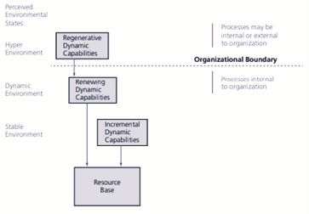
- Hyper Environment (Present - 2018) – Modern era of digital transformation with sustainability requirements along with changing consumer behaviour.

- Dynamic Environment (Transition 2010 - 2017) – Rise of e-commerce.

- Stable environment (Past – Early 2000s) – Zara’s dominance over the market through their efficient end-to-end supply chain mechanism.

- Example of Strategic Paradox (Physical Store Experience vs Online expansion):

Even though online shopping grew among the customers, Zara kept investing heavily on their flagship stores parallelly shows a smart sign of balancing their business by linking physical stores with their digital systems.

External Analysis:

External analysis emphasises on the firm’s ability to assess the market dynamics, regulations and competition. This can be analysed through the “Compliance and Choice” paradox, where the international firms must comply with regulatory rules and compliance regulations while parallelly working on exercising a strategic choice to adapt their environment.
Zara being a fast-fashion global level industry, underwent a digital transformation and sustainability pressure to enter the global markets. This includes complying with the compliance rules of ethical use of manufacturing for maintaining the environmental standards. Zara not only adapts to the concept of ‘strategic choice’ but actively shapes them through its end-to-end supply chain integration with rapid production cycle and use of digital innovations like RFID chips. Operating over 96 countries, Zara to aligning with the local policies while maintain their global brand standards (de Wit 2020, pp. 525–536).

Business Strategy Recommendation – Outside-in Strategy:

It is highly recommended to adopt an outside-in business strategy by Zara, as it focuses on the market responsiveness and customer centric innovation. As mentioned in the case study – Zara: Fast Fashion in the Digital Age, (de Wit 2020, pp. 656–665), the market dominance through digital platforms by retailers like Amazon and changing consumer demands forced Zara to strengthen its adaptability towards the current market standards. The market vs resource paradox, a concept which depends upon aligning internal strength with external market changes (de Wit 2020, pp. 196–207). Zara’s fast fashion model and real-time consumer feedback system helped them provide the sense of their current and target customers. With the help of modern technology like RFID chips Zara would be able to maintain the competitiveness e-commerce market. This approach not only enables Zara to maintain their global brand standards but also creates a balance between market compliance with strategic innovation.

Corporate Strategy Recommendation – Integrated Strategy:

Zara should adopt an integrated Corporate Strategy, which aligns with the “Responsiveness and Synergy” paradox (de Wit 2020, pp. 247–260). as it closely aligns to this strategic type. The paradox of Responsiveness and Synergy highlights the tension between being flexible to respond to local market needs (responsiveness) and leveraging capability sharing among a business unit (synergy). Where Zara excels is integrating its global operations through real-time data systems, centralized logistics, and unified brand management processes that maintain a collection's responsiveness to local preferences. The Integrated Corporate Strategy contrasts a portfolio model which treats each brand as its own entity, or "independent," which can constrain a corporation's speed, efficiency, and consistency across the global network. This Integrated Corporate Strategy enables Zara to coordinate innovation approaches, sustainability practices, and digital transformation strategies to create an overall corporate cohesion and overall strategic agility across the Inditex brands. Therefore, we conclude that an Integrated Corporate Strategy, particularly the paradox of Responsiveness and Synergy (de Wit 2020, pp. 247–260), best positions Zara to be competitively viable and leverage its corporate ownership structure in the face of tectonic change emerging in a global fashion industry driven by technological change.

Appendix 1:

Resource Base/Stock of Assets: (text p.193) | Tangible Resources | RFID chips for real-time global visibility.
 | Intangible resources | Transforming sales and customer feedback into new fashion collection by implementing a data driven approach.
 | (Relational Resources Competences) | Ensuring high quality products and flexible production by having a long-term partnership with local European suppliers.
Activity System/Value Chain:  (text p.192) | Firm Infrastructure | Ensures rapid global coordination through centralised decision making.
 | Human Resource Management | Capture live customer feedback
 | Technology Development | RFID enables live-stock level update.
 | Procurement | Close partnership with local vendors and suppliers.
 | Inbound Logistics | Timely sourcing from local suppliers for minimising warehouse cost.
 | Operations | End-to-end production system leads to time saving.
 | Outbound Logistics | A centralized distribution system for shipping new products twice a week to global outlets.
 | Marketing & Sales | Low-key marketing and high-profile retails outlets.
 | Service | Real-time platform integration offers convenient returns.
Product Offering/Value Proposition: (text p.189) | Products and Segments | Zara Homes for interiors and Bershka for youth fashion.
Core competence (Hamel  and Prahlad reading): |  | Hamel and Prahalad’s concept of embedded knowledge and cross-functional coordination.

Appendix 2:

Porter’s Five Forces analysis (indicate low/ medium/high impact for each)

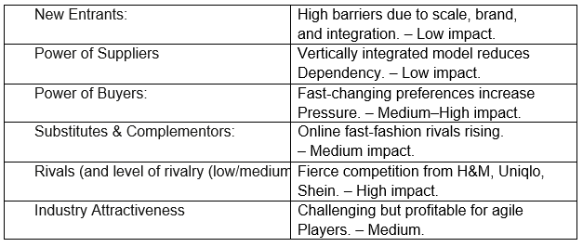

PEST Analysis (indicate low/ medium/high impact for each)

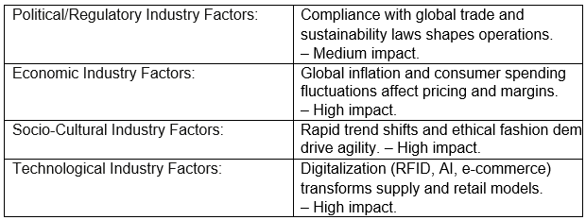

Reference List:

de Wit, B. 2020, ‘Zara: Fast Fashion in the Digital Age’, in Strategy: An International Perspective, Cengage Learning, Hampshire, pp. 656–665.

de Wit, B. 2020, ‘Chapter 4: Business-Level Strategy – The Industry Context (Markets and Resources Paradox)’, in Strategy: An International Perspective, Cengage Learning, Hampshire, pp. 196–207.

de Wit, B. 2020, ‘Chapter 5: Corporate-Level Strategy – The Paradox of Responsiveness and Synergy’, in Strategy: An International Perspective, Cengage Learning, Hampshire, pp. 247–260.

de Wit, B. 2020, ‘Chapter 10: The Industry Context – The Paradox of Compliance and Choice’, in Strategy: An International Perspective, Cengage Learning, Hampshire, pp. 517–562.

